Year group | Term: Autumn 2  (7.5 weeks) |  | Topic: London’s Burning!  SHINE VALUE: Success (determination, perseverance, ambition)
Subject | National Curriculum |  | Key texts &  web links | Knowledge  We know that… |  | Skills  We are able to… |  | Outcome/s  Exit Point
Year 1  English | Non-Fiction: Non-Chronological Report
 | Word Aware Words: sights, palace, London, castle, jewels, dome, haunted, tower, old-fashioned, tour bridge, chimes, crests, theatre
 | Spoken language:  - Listen and respond  - Ask relevant questions  - Build vocabulary  - Participate in discussions, presentations, performances, role-play, improvisations and debates  Reading comprehension:  - Listen to and discuss a wide range of poems, stories and non-fiction at a level beyond that at which can be read independently  - Retell stories and consider their particular characteristics  - Make inferences on the basis of what is being said and done  - Predict what might happen on the basis of what has been read so far Participate in discussion about what has been read to them  Writing Composition:  - Compose a sentence orally before writing it  - Sequence sentences to form short narratives  - Re-read what they have written to check that it makes sense  - Discuss what they have written with the teacher or other pupils  - Read aloud their writing clearly enough to be heard by their peers and the teacher |  | Katie in London  By Jams Mayhew  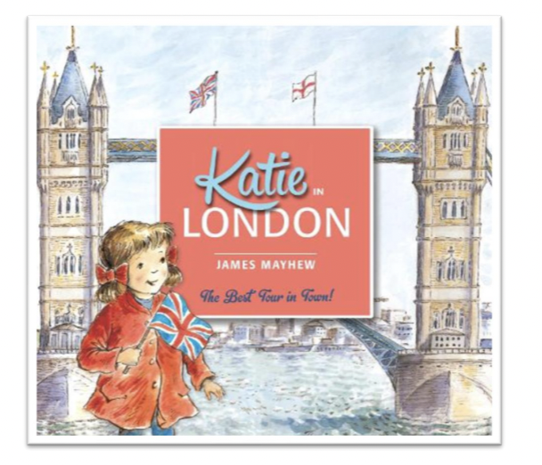 | Gateway Keys  - Combine words to make sentences  - Use capital letters for names of people and the personal pronoun ‘I’ L  - eave spaces between words  - Begin to use capital letters and full stops  Mastery Keys  - Join words using and  - Punctuate sentences using a capital letter and a full stop  - Use capital letters for names of people and places • Sequence sentences (link ideas or event by pronoun) Opportunity to apply word skills:  - Spell words containing phonemes already taught  - Use plural noun suffixes -s and -es  Feature Keys  - Write simple sentences linked to the topic Write in the present tense  - Link ideas through subject or pronoun |  |  |  | Writing outcome: To write a non-chronological report about London using information gathered from the texts.  Greater depth writing outcome:  To write a non-chronological report about London using information gathered from the texts including a fun fact about one of the sights.
Year 2  English | Non-Fiction: Information Report
 | Word Aware Words: capital, bustling, population, tar, pitch, cobbled, sewer, administrator, Navy, coronation, fire break, gunpowder, demolish, hand squirt, memorial, junction, rose, raged, Mayor, substance
 | Common Exception Words: improve, only, people, even, water, poor, could, busy, whole, would, hour, sure, because, most, fast, many, beautiful, money
 | Spoken language:  - Listen and respond  - Ask relevant questions  - Build vocabulary  - Maintain attention and participate actively in collaborative conversations  Reading comprehension:  - Discuss the sequence of events in books and how items of information are related  - Read non-fiction books that are structured in different ways  - Draw on what is already known or on background information and vocabulary provided by the teacher  - Make inferences on the basis of what is being said and done  - Answer and ask questions  - Participate in discussions about books, poems and other works  - Explain and discuss their understanding of books, poems and other material  Writing composition:  - Write for different purposes  - Make simple additions, revisions and corrections (greater depth only)  - Evaluate writing with the teacher and other pupils  - Proofread to check for errors in spelling, grammar and punctuation  - Read aloud with intonation |  | The Great Fire of London  By  Emma Adams & James Weston Lewis  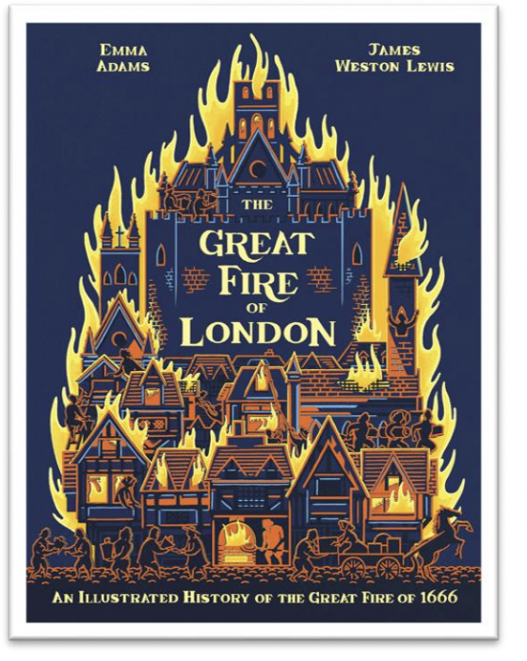 | Gateway Keys  - Use punctuation correctly – full stops, capital letters  - Use expanded noun phrases to describe and specify  - Use subordination (because) and coordination (and)  Mastery Keys  - Use co-ordination (but, or)  - Add -ly to turn adjectives into adverbs  - Use commas to separate items in a list  Feature Keys  - Specific vocabulary linked to the topic  - Clear and precise description  - Present tense (past tense for historical facts)  - Title  - Sub-headings  - Introduction  - Grouped information  - Facts from research |  |  |  | Writing outcome: To write a fact sheet about London and the events of the fire.  Greater depth writing outcome: To have greater choice in how to represent the information for example, in the choice of layout and sub-headings used.
Year 1  Maths | Number: Addition and Subtraction within 10
 | Word Aware Words: part, whole, add, subtract, tens, ones, more, less
 | Addition and Subtraction:  - Read, write and interpret mathematical statements involving addition (+), subtraction (–) and equals (=) signs  - Represent and use number bonds and related subtraction facts within 20  - Add and subtract 1-digit and 2-digit numbers to 20, including zero |  | White Rose  Year 1  Autumn Block 2 | Ready to progress criteria:  Place Value:  Count on from any number  Count backwards within 10  Know fewer, more, same, less than, greater than, equal to  Compare numbers  Order objects and numbers  Use a number line
Year 2  Maths | Number: Addition and Subtraction Geometry: Shape
 | Word Aware Words: add, subtract, 1-digit, 2-digits, 10 more, 10 less
 | Addition and Subtraction:  - add and subtract numbers using concrete objects, pictorial representations, and mentally, including:  - a two-digit number and ones  - a two-digit number and tens  - two two-digit numbers  - adding three one digit numbers  - solve problems with addition and subtraction: using concrete objects and pictorial representations, including those involving numbers, quantities and measures  - applying their increasing knowledge of mental and written methods  Shape  - Identify and describe the properties of 2-D shapes, including the number of sides, and line symmetry in a vertical line  - Identify and describe the properties of 3-D shapes, including the number of edges, vertices and faces  - Identify 2-D shapes on the surface of 3-D shapes  - Compare and sort common 2-D and 3-D shapes and everyday objects |  | White Rose  Year 2  Autumn Block 2 & 3 | - Bonds to 10  - Fact families - addition and subtraction bonds within 20  - Related facts  - Bonds to 100 (tens)  - Add and subtract 1s  - Add by making 10  - Add three 1-digit numbers  - Add to the next 10  - Add and subtract across 10  - Subtract a 1-digit number from a 2-digit number (across a 10) 10  - More and 10 less  - Add and subtract 10s  - Add two 2-digit numbers (not across a 10)  - Add two 2-digit numbers (across a 10)  - Subtract two 2-digit numbers (not across a 10)  - Subtract two 2-digit numbers (across a 10)  - Mixed addition and subtraction  - Compare number sentences  - Missing number problems  - Recognise 2-D and 3-D shapes  - Count sides & Vertices on 2-D shapes  - Draw 2-D shapes  - Lines of symmetry on shapes  - Use lines of symmetry to complete shapes  - Sort 2-D shapes  - Count faces, edges and vertices on 3-D shapes  - Sort 3-D shapes  - Make patterns with 2-D and 3-D shapes
Year 1  History  DT  Science  Computing | The Big Question: What happened in Pudding Lane?
 | Word Aware Words: fire, great, London, sequence, event, past, bakery,
 | In History:  Know and understand about:  - Changes within living memory  - Events beyond living memory that are significant nationally or globally  In Computing:  - Use technology purposefully to create, organise, store, manipulate and retrieve digital content.  - Recognise common uses of information technology beyond school  - Online safety (links with PSHE)  In DT (joins)  - Design purposeful, functional, appealing products for themselves and other users based on design criteria  - Select from and use a range of tools and equipment to perform practical tasks [for example, cutting, shaping, joining and finishing]  - Select from and use a wide range of materials and components, including construction materials, textiles and ingredients, according to their characteristics  - Evaluate their ideas and products against design criteria  In Science:  - Describe the simple physical properties of a variety of everyday materials  - Observe closely, using simple equipment  - performing simple tests  - Use their observations and ideas to suggest answers to questions  - Gather and record data to help in answering questions  - Find out about Scientists that develop new materials (Non- statutory) |  | Websites:  https://www.london-fire.gov.uk/museum/history-and-stories/the-great-fire-of-london/#:~:text=The%20Great%20Fire%20of%20London%20started%20on%20Sunday%2C%202%20September,house%20was%20a%20blazing%20inferno.  The Great Fire of London 1666 - YouTube  https://www.literacyshed.com/puddinglane.html#  https://www.bbc.co.uk/teach/school-radio/history-great-fire-of-london-image-slideshow/zdttmfr  Magic Grandad  https://www.youtube.com/watch?v=VarSSAwiimU | - Know the key events of the Great Fire of London  (2nd September 1666, started in a bakery in Pudding Lane. Thomas Farynor owned the bakery, it was a long, dry Summer and wind spread the fire, the houses burnt quickly, it took 4 days to extinguish, they used buckets of water and fire hooks, most of London was destroyed)  - Understand that houses, streets and bakeries were different in 1666 to now  - Know the hazards of fire and how to stay safe  - Know how to use iPad Apps  Popplet, Pic Collage  - Use Augmented Reality technology  - Know that Louis Pasteur was a scientist that studied germs. His discoveries helped to save millions of lives. |  | - Compare the past with now  - Create a time line of events  - Insert an image  - Add text  - Change the font style, size and colour  - Save and retrieve digital content  - Design a product, thinking carefully about the colour, pattern and shape.  - Use a running stich to sew fabric together  - Use a range of design techniques to make a product.  - Make observations  - Ask and answer questions |  | Double page spread  FS: design, make and build landmarks of London
Year 2  History  GeographyDT  Science  Computing | The Big Question: Why did London burn in 1666?
 | Word Aware Words: diary, past, burn, events, timeline, effect, rebuild, modern
 | In History:  Know and understand about:  - Events beyond living memory that are significant nationally or globally.  - The lives of significant individuals in the past who have contributed to national and international achievements.  In Computing:  - Use technology purposefully to create, organise, store, manipulate and retrieve digital content.  - Recognise common uses of information technology beyond school  - Online safety (links with PSHE)  In DT (joins)  - Design purposeful, functional, appealing products for themselves and other users based on design criteria  - Select from and use a range of tools and equipment to perform practical tasks [for example, cutting, shaping, joining and finishing]  - Select from and use a wide range of materials and components, including construction materials, textiles and ingredients, according to their characteristics  - Evaluate their ideas and products against design criteria  - Build structures, exploring how they can be made stronger, stiffer and more stable  In Science:  - Identify and compare the suitability of a variety of everyday materials, including wood, metal, plastic, glass, brick, rock, paper and cardboard for particular uses  - Find out about Scientists that develop new materials (Non- statutory)  Geography:  - Use basic geographical vocabulary to refer to key human features, including: city, town, village, factory, farm, house, office, port, harbour and shop  - Use aerial photographs and plan perspectives to recognise landmarks and basic human and physical features |  | Zoom Through History Workshop  Thursday 2nd November  https://www.zoomthroughhistory.com/home  https://www.london-fire.gov.uk/museum/history-and-stories/the-great-fire-of-london/#:~:text=The%20Great%20Fire%20of%20London%20started%20on%20Sunday%2C%202%20September,house%20was%20a%20blazing%20inferno.  The Great Fire of London 1666 - YouTube  https://www.literacyshed.com/puddinglane.html#  https://www.bbc.co.uk/teach/school-radio/history-great-fire-of-london-image-slideshow/zdttmfr  Magic Grandad  https://www.youtube.com/watch?v=VarSSAwiimU | - Know that Samuel Pepys, a clerk to the Royal Navy, observed the fire and kept a diary.  - Know the key events of the Great Fire of London  - Understand that the fire spread so quickly because of the weather, the material of the houses, the houses were close together and there was no organised fire brigade  - The rebuilding of the city helped to shape modern London and building regulations across the country.  - Know how I can use the internet to find things out.  - identify devices I could use to access information on the internet.  - Give simple examples of how to find information (e.g. search engines, voice activated searching).  - Use Augmented Reality technology  - Know that Dr Robert Hooke was a leader in the plans to rebuild after the Great Fire of London in 1666.  - Know that his works included the designing the dome on St Paul's Cathedral, London and redesigning London's streets into a grid pattern with wide streets. |  | - Understand the past can be ordered and create a time line of events  - Use technology, books and diaries to find out about the past  - Compare the past with now  - Use video to record events  - Insert text to annotate a video  - Save and retrieve digital content  - Design, make and evaluate when creating a purposeful product  - Use different joins to join materials |  | Double page spread  FS: Design, make and burn houses on an open fire
Year 1  Music  Weekly | Pitch and Tempo Theme: Superheroes
 | Word Aware Words: pitch, high, low, tempo, fast, slow, performance, compose
 | - Use voices expressively and creatively by singing songs and speaking chants and rhymes.  - Play tuned and untuned instruments musically.  - Listen with concentration and understanding to a range of high quality (live) and recorded music.  - Experiment with, create, select and combine sounds using the interrelated dimensions of music. |  | Kapow Primary  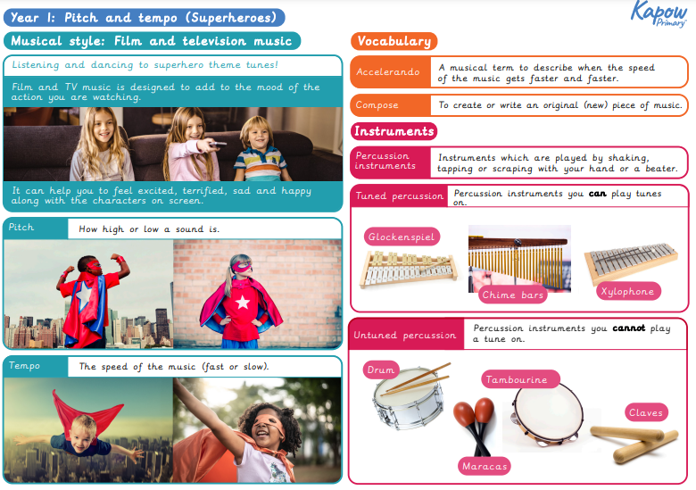 | - Know the musical terms pitch and tempo  - Know that the term pitch means high and low notes  - Know that the term tempo is the speed that a note is played and that this can be fast or slow |  | - Identify high and low notes  - Perform confidently as part of a group  - Compose as part of a group  - Say what I am good at and what I need to improve  - Create a pattern using two pitches |  | Perform a ‘Superhero theme tune’.
Year 2  Music  weekly | Ocarinas: London’s Burning
 | Word Aware Words: timbre, dynamics, tempo
 | - Use voices expressively and creatively by singing songs and speaking chants and rhyme  - Play tuned and untuned instruments musically  - Listen with concentration and understanding to a range of high quality (live) and recorded music  - Experiment with, create, select and combine sounds using the interrelated dimensions of music |  | Ocarinas  BBC: The Great Fire of London  http://teach.files.bbci.co.uk/schoolradio/gfol_notes.pdf | - Know that a composer is someone who creates music and writes it down.  - Explain the musical vocabulary, tempo, timbre and dynamics |  | - Recognise timbre changes in music they listen to.  - Begin to use musical vocabulary to describe music.  - Suggest improvements to their own and others’ work.  - Play simple melodies from five or more notes.  - Choose appropriate dynamics, tempo and timbre for a piece of music.  - Use their voices expressively when singing, including the use of basic dynamics (loud and quiet).  - Perform expressively using dynamics and timbre to alter sounds as appropriate. |  | Perform a simple tune with a tuned instrument (ocarina)  London’s Burning
Year 1  RE  Weekly | The Ultimate Question: Why is Christmas important to Christians?
 | Word Aware Words: Jesus, Nativity, Bethlehem, advent, Christianity
 | AT1  Name the different beliefs and practices of Christianity.  Retell some of the religious and moral stories from the Bible.  Begin to understand what it looks like to be a person of faith.  Begin to use key words and vocabulary.  AT2  Talk about and find meanings behind different beliefs and practices. |  | 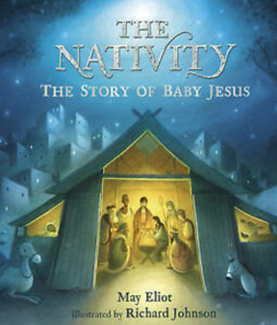 | - Understand the meaning behinds some of the symbols of Christmas, e.g. gifts.  - Know that the symbols of Christmas are important to Christians. |  | Share with each other their understanding of the symbols of Christmas |  | Retell the story of the Nativity
Year 2  RE  Weekly | The Ultimate Question: Why is light such an important symbol? Focus is Diwali, Hanukah and Christmas
 | Word Aware Words: Celebration, festival, light, symbols, tradition, hope
 | AT1  Become familiar with key words and vocabulary.  Begin to name the different beliefs and practices.  Show how different people celebrate aspects of religion.  AT2  Begin to talk about and find meanings behind different beliefs and practices.  Ask or respond to questions about what individuals and faith communities do. |  | Diwali  https://www.youtube.com/watch?v=KZU6M4EisyA  https://www.youtube.com/watch?v=pp59n0So-XE  Hanukah  https://www.bbc.co.uk/newsround/35030671  https://www.youtube.com/watch?v=zsXQfCeMHs8  Christmas  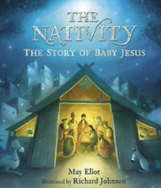 | - Know that all religions use symbols to share a message of love and hope.  - To understand the importance of light in different religions  - Hope means to have a desire for things to change for the better. |  | Talk about the reasons people of faith celebrate light |  | Make a Christingle and create a circle of light during a Christingle service
Year 1  PSHE  Weekly | Mental Wellbeing: Being Me in My World
 | Word Aware Words: emotion, lonely, scared, angry
 | Working together  Respectful Relationships  - To recognise and communicate feelings to others  - To listen to, reflect on and respect other people’s views and feelings  - To have knowledge of how to deal/cope with different emotions (mindfulness opportunity) | - Angry: ‘Why Lose Your Temper?’  - Loneliness: ‘Lonely’  - Worried and Scared: ‘Everybody Feels SCARED’ |  |  | Online safety  - Understand the difference between online and offline.  - Understand what information I should not post online.  - Know what the techniques are for creating a strong password.  - Know that you should ask permission from others before sharing about them online and that they have the right to say ‘no.’  - Understand that not everything I see or read online is true |  | - Recognise devices that are connected to the internet.  - Understanding that we are connected to others when using the internet.  - Understand some of the ways we can use the internet.  - When using the internet to search for images, learning what to do if they come across something online that worries them or makes them feel uncomfortable.  - Understanding how to interact safely with others online.  - Recognising how actions on the internet can affect others.  - To be able to recognise what a digital footprint is and how to be careful about posting online.
Year 2  PSHE  Weekly | Mental Wellbeing: Being Me In My World
 | Word Aware Words: emotion, bad tempered, embarrassed, frustrated, jealous, brave
 | Working together  Respectful Relationships  - Recognise and communicate feelings to others  - Listen to, reflect on and respect other people’s views and feelings  - Have knowledge of how to deal/cope with different emotions (mindfulness opportunity) | - Jealous: ‘Katie Morag and the Tiresome Ted’  - Frustrated: ‘The Bad Tempered Ladybird’  - Embarrassed:  - Courage: ‘Brave’ |  |  | Online safety  - Know that the internet is many devices connected to one another.  - Know what to do if you feel unsafe or worried online – tell a trusted adult.  - Know that people you do not know on the internet (online) are strangers and are not always who they say they are.  - Know that to stay safe online it is important to keep personal information safe.  - Know that ‘sharing’ online means giving something specific to someone else via the internet and ‘posting’ online means placing information on the internet. |  | - Identify whether information is safe or unsafe to be shared online.  - Learn how to create a strong password.  - Learn to be respectful of others when sharing online and ask for their permission before sharing content.  - Learn strategies for checking if something they read online is true.  - Understand how to stay safe when talking to people online and what to do if they see or hear something online that makes them feel upset or uncomfortable.
Year 1  PE  Weekly | Games: Ball skills
 | Word Aware: bounce, control, throwing, catching
 | - Refine the skills of running successfully, change directions, and develop side stepping. Throw, catch and aim on the move. |  | Cambridgeshire Scheme of Work for Primary Schools  Year 1 | - Practise and develop rolling skills (sending and receiving)  - Bouncing the ball – standing still and bouncing the ball and then moving and bouncing the ball.  - Throwing and catching  - Throwing and catching with a partner  - Modified games (include skills taught within the unit)
 | Gymnastics: Balancing
 | Word Aware: still, big, small, pointed toes
 | - Master basic movements including running and jumping.  - Develop balance, agility and co-ordination, and begin to apply these in a range of activities. |  | Premier Sports Coach | - Still balances  - Partner balances  - Create and perform a sequence of balances  - Travel across a piece of equipment and balance
Year 2  PE  Weekly | Games: Ball skills
 | Word Aware: underarm, overarm, distance, send, receive
 | - Master basic movements including running, jumping, throwing and catching, as well as developing balance, agility and co-ordination, and begin to apply these in a range of activities. |  | Cambridgeshire Scheme of Work for Primary Schools  Year 2 | - Underarm and overarm throwing and catching  - Aiming at a target  - Sending and receiving  - Modified games (include skills taught within the unit)
 | Gymnastics: Balances
 | Word Aware: link, unison, match
 | - Master basic movements including running and jumping.  - Develop balance, agility and co-ordination, and begin to apply these in a range of activities. |  | Premier Sports Coach | - Points and patches  - Partner balance (counter tension)  - Mirroring balances  - Create and perform a sequence of balances  - Create a sequence of balances on apparatus

