Year group | Term: Summer 1 | Topic: Ahoy There!  SHINE VALUE: Enthusiastic (curiosity, imagination, motivation)
Subject | National Curriculum | Key texts &  web links | Knowledge  We know that… |  | Skills  We are able to… | Outcome/s  Exit Point
Year 1  English | Non-chronological Report
 | Word Aware Words: swept, jellyfish, tentacles, floated, ordinary, tongue, barnacles, vast, cave, creature, skimmed, hummed, brave, steam, spout, bobbed, gently, calm, carefree, beady, paddle-shaped flippers
 | Spoken language:  - Build vocabulary  - Articulate and justify answers  - Give well-structured descriptions, explanations and narratives  - Participate in discussions, presentations, performances, role play, improvisations and debates  Reading comprehension:  - Learn to appreciate rhymes and poems Recite some rhymes and poems by heart Discuss word meanings, linking new meanings to those already known  - Make inferences on the basis of what is being said and done  - Predict what might happen on the basis of what has been read so far  - Participate in discussion about what has been read to them  - Explain clearly understanding of what is read to them  Writing composition:  - Say out loud what is going to be written about  - Sequence sentences to form short narratives  - Re-read what they have written and check that it makes sense  - Discuss what has been written with the teacher or other pupils  - Read writing aloud clearly enough to be heard by peers and the teacher  - Spell words containing phonemes already taught  - Spell common exception words | Somebody Swallowed Stanley  By  Sarah Roberts  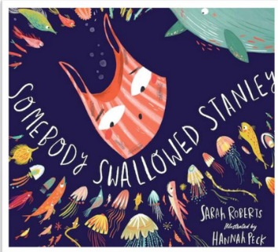 | Gateway Keys  - Join words and clauses using and  - Punctuate sentences using a capital letter and a full stop, question mark or exclamation mark  - Add suffixes where no change is needed to the root word e.g –ed, -er, -ing, -est  Mastery Keys  - Join words and clauses  using and  - Punctuate sentences using  a capital letter and a full  stop, question mark or  exclamation mark  - Add suffixes where no  change is needed to the  root word e.g. ed, -ing, -er,  -est  - Change the meaning of  verbs and adjectives by  adding the prefix un  Feature Keys  - Write simple sentences linked to the topic  - Write in the present tense  - Link ideas through subject or pronoun e.g. Bats are black. They fly at night |  |  | Writing outcome:  To write information about the sea animals looked at in the texts.  Greater depth writing outcome:  To write information about the sea animals looked at in the texts including sections on how to protect them.
Year 2  English | Persuasion: Tidy
 | Word Aware Words: forest, badger, patch, grooming, untangled, knot, burr, polished, scoured, feat, scrappy, undertook, mighty, flood, concrete, rakers, rumbled, churned, mixer, succeeded
 | Spoken language:  - Articulate and justify answers  - Maintain attention and participate in collaborative conversations  - Speak audibly and fluently  - Participate in discussions, presentations, performances, role-play, improvisations  and debates  Reading comprehension:  - Listen to, discuss and express views about a wide range of books at a level beyond that which can be read independently  - Discuss the sequence of events in books and how items of information are related  - Draw on what is already known and on background information and vocabulary provided by the teacher  - Predict what might happen on the basis of what has been read so far  Writing composition:  - Write narratives about personal experiences and those of others (real and fictional)  - Write about real events  - Write for different purposes  - Plan or say out loud what is going to be written about  - Make simple additions, revisions and corrections  - Evaluate writing with the teacher and other pupils  - Proofread to check for errors in spelling, grammar and punctuation  - Re-read to check that their writing makes sense | Tidy by Emily Gravett  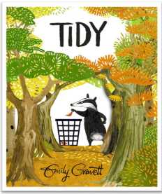 | Gateway Keys  - Use the progressive form of verbs in the present and past tense  - Some use of subordination (because, when) and coordination (and, but)  - Use punctuation correctly (as taught so far)  - Write sentences with different forms: statement, question, exclamation, command  Mastery Keys  - Use subordination (if, that)  - Add -er and -est to adjectives  - Use homophones and near homophones  - Use punctuation correctly – apostrophes for contracted forms  Feature keys  - Include detail and description to inform the reader  - Use a range of sentence forms to address the reader  - Write in 1st person  - Include personal comments and own viewpoint  - Use openings and closings e.g. dear, opening statement to state why we are writing, from |  |  | Writing outcome:  To write a persuasive letter in role as Pete.  Greater depth writing outcome:  To write a persuasive letter in role as another animal who lives in the forest. They can include inference of feelings about their homes being destroyed and made untidy.
Year 1  Maths | Number: Multiplication and Division, Fractions Geometry: position and direction
 | Word Aware Words: multiply, divide, double, fraction, half, quarter, left, right
 | Multiplication and Division  - Count, read and write numbers to 100 in numerals; count in multiples of 2s, 5s and 10s  - Solve one-step problems involving multiplication and division by calculating the answer using concrete objects, pictorial representations and arrays with the support of the teacher  Fractions  - Recognise, find and name a half as one of two equal parts of an object, shape or quantity  - Recognise, find and name a quarter as one of four equal parts of an object, shape or quantity  Geometry:  - Describe position, direction and movement, including whole, half, quarter and three-quarter turns  - Use the language of position, direction and motion, including: left and right, top, middle and bottom, on top of, in front of, above, between, around, near, close and far, up and down, forwards and backwards, inside and outside (non-statutory guidance)  - Practise counting (1, 2, 3…), ordering (for example, 1st, 2nd, 3rd …) (non-statutory guidance) | White Rose  Year 1  Summer Block 1,2,3  NCETM - teaching for mastery |  | Multiplication and Division  - Count in 2s,10s, 5s  - Make equal groups  - Add equal groups  - Make doubles  - Make arrays  Fractions  - Recognise half an object or a shape  - Find half an object or shape  - Recognise half a quantity  - Find half a quantity  - Recognise quarter of an object or a shape  - Find quarter of an object or shape  - Recognise quarter of a quantity  - Find quarter of a quantity  Geometry:  - Describe turns  - Describe position – left and right  - Describe position – forwards and backwards  - Describe position – above and below  - Ordinal numbers
Year 2  Maths | Number: Addition and Subtraction Measure: Time
 | Word Aware Words: half, quarter, minute, hour, o’clock, add, subtract
 | Time  - Tell and write the time to five minutes, including quarter past/to the hour and draw the hands on a clockface to show these times  - Know the number of minutes in an hour and the number of hours in a day  Addition and Subtraction  - Add and subtract within 100 by applying related one-digit addition and subtraction facts: add and subtract only ones or only tens to/from a two-digit number.  - Add and subtract within 100 by applying related one-digit addition and subtraction facts: add and subtract any 2 two-digit numbers.  Mass, Capacity and Temperature  - choose and use appropriate standard units to estimate and measure length/height in any direction (m/cm); mass (kg/g); temperature (℃); capacity (litres/ml) to the nearest appropriate unit, using rulers, scales, thermometers and measuring vessels  - compare and order lengths, mass, volume/capacity and record the results using >, < and =. | White Rose  Year 2  Summer Block 1,2  NCETM - teaching for mastery | Time  - O’clock and half past  - Quarter past and quarter to  - Tell the time past the hour  - Tell the time to the hour  - Tell the time to 5 minutes  - Minutes in an hour  - Hours in a day  Addition and Subtraction  - Add across a 10  - Subtract across a 10  - Subtract from a 10  - Subtract 1-digit number from a 2-digit number (across a 10)  - 10 more, 10 less  - Add and subtract 10s  Mass, Capacity and Temperature  - Compare Mass  - Measure in grams  - Measure in kilograms  - Four operations with mass  - Compare volume and capacity  - Measure in millilitres  - Measure in litres  - Four operations with volume and capacity  - Temperature
Year 1  Geography  DT  Computing  Science  4 weeks | The Big Question: What would a seagull discover at the coast?
 | Word Aware Words: material, axle, wheel, coast, cliff, sea, land, sand, beach, seaside, debug
 | In Geography:  Exploring the UK:  Features of the seaside  Locational knowledge  Name, locate and identify characteristics of the four countries and capital cities of the United Kingdom and its surrounding seas.  Physical knowledge  Understand geographical similarities and differences through studying the human and physical geography of a small area of the United Kingdom.  Human and physical geography  Use basic geographical vocabulary to refer to key physical features, including: beach, cliff, coast, sea, ocean and human features, including: city, town, village, factory, farm, house, office, port, harbour and shop.  Use aerial photographs and plan perspectives to recognise landmarks and basic human and physical features; devise a simple map.  In Computing:  Programming: Beebots  - Understand what algorithms are, how they are implemented as programs on digital devices, and that programs execute by following precise and unambiguous instructions.  - Create and debug simple programs  - Use logical reasoning to predict the behaviour of simple programs  In DT: Moving vehicles  Design  - design purposeful, functional, appealing products for themselves and other users based on design criteria  - generate, develop, model and communicate their ideas through talking, drawing, templates, mock-ups and, where appropriate, information and communication technology  Make  - select from and use a range of tools and equipment to perform practical tasks [for example, cutting, shaping, joining and finishing]  - select from and use a wide range of materials and components, including construction materials, textiles and ingredients, according to their characteristics  Evaluate  - explore and evaluate a range of existing products  - evaluate their ideas and products against design criteria Technical knowledge  - explore and use mechanisms [for example, levers, sliders, wheels and axles], in their products.  In Science:  - Distinguish between an object and the material from which it is made.  - Identify and name a variety of everyday materials, including wood, plastic, glass, metal, water, and rock  - Describe the simple physical properties of a variety of everyday materials  - Compare and group together a variety of everyday materials on the basis of their simple physical properties. | Google maps:  https://www.google.co.uk/maps/@52.5850067,-0.2321658,14z  Beach cams:  https://www.thebeachguide.co.uk/webcams  Globes, maps & atlases  Kapow: Computing | - Know that not all places are the same  - Know that there are places beyond our street  - Understand that Peterborough has a different landscape to Hunstanton  - Understand the terms wheel and axle  - Know the basic functions of a Bee-Bot.  - Know that algorithms move a Bee-Bot accurately to a chosen destination.  - Know how you can use a camera/tablet to make simple videos. |  | - Locate places on a map using symbols  - Use positional and directional language to reach a destination  - Compare and contrast  - Use logical reasoning to predict the behaviour of simple programs.  - Follow a basic set of instructions.  - Assemble instructions into a simple algorithm.  - Program a floor robot to follow a planned route.  - Learn to debug instructions when things go wrong.  - Use programming language to explain how a floor robot works.  - Learn to debug an algorithm in an unplugged scenario | Double page spread about the seaside  Computing  - Recognise cause and effect when pressing buttons on a Bee-Bot.  - Discuss and demonstrate how the Bee-Bot works.  - Record video, ensuring everyone is in the shot.  - Give several clear instructions in sequence.  - Program a Bee-Bot to reach a destination.  - Identify and correct mistakes in their programming.  Create a moving vehicle (carousel)
Year 2  Geography  DT  Computing  Science  4 weeks | The Big Question: Where would you like to live in the world?
 | Word Aware Words: equator, continent, ocean, climate, North, South, algorithm
 | In Geography:  Exploring the World:  Continents & Seas  North and South  Locational knowledge  Name and locate the world’s seven continents and five oceans.  Human and physical geography  Identify the location of hot and cold areas of the world in relation to the Equator and the North and South Poles.  Use basic geographical vocabulary to refer to key physical features, including: sea, ocean.  Geographical skills and fieldwork  Use world maps, atlases and globes to identify continents and oceans studied at this key stage.  Use simple compass directions (North, South, East and West) and locational and directional language [for example, near and far; left and right], to describe the location of features and routes on a map  Recognise landmarks using aerial photographs  Understand geographical similarities and differences of a small area in the UK and a contrasting country  In Computing: Programming 2: Scratch jr  - Use logical reasoning to predict the behaviour of simple programs  - Use technology purposefully to create, organise, store, manipulate and retrieve digital content  - Recognise common uses of information technology beyond school  In DT: Mechanisms: levers and sliders  Pop-up Pirates  Design  - design purposeful, functional, appealing products for themselves and other users based on design criteria  - generate, develop, model and communicate their ideas through talking, drawing, templates, mock-ups and, where appropriate, information and communication technology.  Make  - select from and use a range of tools and equipment to perform practical tasks [for example, cutting, shaping, joining and finishing]  Evaluate  - explore and evaluate a range of existing products  - evaluate their ideas and products against design criteria  Technical knowledge  - build structures, exploring how they can be made stronger, stiffer and more stable  - explore and use mechanisms [for example, levers, sliders, wheels and axles], in their products.  In Science:  - Identify and compare the suitability of a variety of everyday materials  - Observe closely, using simple equipment.  - Perform simple tests. | Google maps:  https://www.google.co.uk/maps/@52.5850067,-0.2321658,14z  Globes, maps & atlases  Kapow: Computing  https://www.scratchjr.org/ | - Name and locate the world’s 7 continents and 5 oceans  - Understand that the equator effects the climate of different parts of the world  - Know that coding is writing in a special language so that the computer understands what to do.  - Understand that the character in ScratchJr is controlled by the programming blocks.  - Know that you can write a program to create a musical instrument or tell a joke.  - Know the difference between transparent, translucent, and opaque materials |  | - Read a map Locate places on maps, globes, and atlases  - Use symbols on a map  - Devise a simple map  - Recognising that buttons cause effects and that technology follows instruction  - Explaining what an algorithm is.  - Following an algorithm.  - Create a clear and precise algorithm.  - Learn that programs execute by following precise instructions.  - Incorporate loops within algorithms.  - Use logical thinking to explore software, predicting, testing and explaining what it does.  - Use an algorithm to write a basic computer program.  - Use loop blocks when programming to repeat an instruction more than once.  - Design, make and evaluate when creating a purposeful product  - Identify and compare the suitability of a variety of everyday materials | - Double page spread to include  levers and sliders  Computing  - Use a code to create an animation of an animal
Year 1  Music  Weekly | Musical Vocabulary Theme: By The Sea
 | Word Aware Words: pitch, timbre, vocal, dynamics, tempo
 | - Use voices expressively and creatively by singing songs and speaking chants and rhymes  - Play tuned and untuned instruments musically.  - Listen with concentration and understanding to a range of high quality (live) and recorded music  - Experiment with, create, select and combine sounds using the interrelated dimensions of music. | Kapow Primary  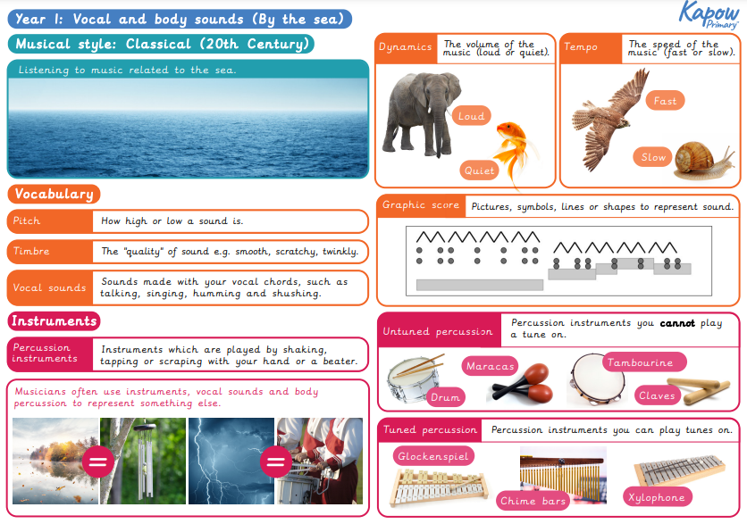 | - To understand that music can be used to represent an environment  - To understand that music can be used to represent the changes in the environment  - To understand the terms; pitch, timbre, tempo and dynamics |  | - Match instruments with seaside sounds  - Use my body to create seaside sounds  - Recognise and use dynamics and tempo  - Play loud and quiet sounds on an instrument and with my voice  - Play fast and slow sounds on an instrument and with my voice  - Say how the volume (dynamics) and speed (tempo) changes the mood  - Create a simple graphic score (picture based) | Create seaside soundscape by writing music and performing from what has been written
Year 2  Music  Weekly | British Sounds and Songs Theme: On This Island
 | Word Aware Words: dynamics, pitch, structure, texture, timbre, tempo
 | - Use voices expressively and creatively by singing songs and speaking chants and rhyme  - Play tuned and untuned instruments musically  - Listen with concentration and understanding to a range of high quality (live) and recorded music  - Experiment with, create, select and combine sounds using the interrelated dimensions of music | Kapow Primary  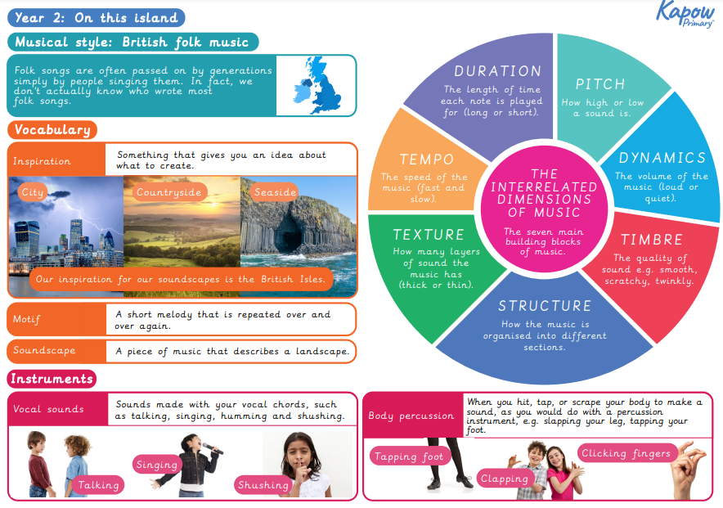 | - To understand the terms; pitch, timbre, tempo and dynamics, duration and texture  - To understand that the structure of a piece of music has a beginning, middle and end. |  | - Sing a song confidently  - Create a musical soundscape  - Use musical vocabulary to talk about the music I hear and play  - I can find multiple ways of making the same sound  - Compose a piece of music with structure (beginning, a middle and an end).  - Evaluate a group composition | Compose and perform a structured soundscape (seaside – country -city) confidently and accurately as part of a group.
Year 1  RE  Weekly | The Ultimate Question: How does being a Muslim make a difference to a family?
 | Word Aware Words: Muslim, Islam, family, faith, Adhan, Qur’an, prayer, mosque
 | (inc. The Mosque)  AT1:  - To begin to name the different beliefs and practices of Islam.  - To show how different people celebrate aspects of religion.  - To become familiar with key words and vocabulary related to Islam.  AT2:  - To begin to talk about and find meanings behind different beliefs and practices of Islam.  - To ask or respond to questions about what individuals and faith communities do. | My Muslim Faith by Khadijah Knight | - Know how Muslims welcome babies and reflect on how names can be part of a person's identity and beliefs.  - Know that Muslim children learn how to behave from their religion and reflect on who teaches them how to behave and live a good life.  - Explain some of the religious aspects of a Muslim's daily life including wudu, prayer, reading the Qur’an and going to Mosque.  - Reflect on what is important to Muslims and themselves.  - Know the Mosque is a special place for Muslims and consider other places that are special to others and why. |  | - Ask and answer questions.  - Talk about Muslim beliefs and practices. | Reflections
Year 2  RE  Weekly | The Ultimate Question: How do Christians, Muslims and Sikhs celebrate weddings?
 | Word Aware Words: Christian, Muslim, Sikh, celebrate, wedding, symbol, marriage
 | (inc. symbols, clothes etc)  AT1  - Name the different beliefs and practices of Christianity, Sikhism and Islam.  - Begin to use key words and vocabulary.  AT2  - Talk about and find meanings behind different beliefs and practices.  - Ask and respond to questions about what individuals and faith communities do.  - Express their own ideas creatively. |  | - Know why people get married.  - Know how Christians, Sikhs and Muslims celebrate weddings.  - Understand the different practices.  - Understand why marriage is important to Christians, Sikhs and Muslims. |  | - Ask and answer questions.  - Compare the similarities and differences in Christian, Islamic and Sikh weddings.  - Identify religious symbols associated with these weddings and say what they mean. | Reflections
Year 1  PSHE  Weekly | People Who Care For Me: Families
 | Word Aware Words: family, love, respect, care
- That families are important for children growing up because they can give love, security and stability
- That others’ families, either in school or in the wider world, sometimes look different from their family, but that they should respect those differences and know that other children’s families are also characterised by love and care.
- How to recognise if family relationships are making them feel unhappy or unsafe, and how to seek help or advice from others if needed.
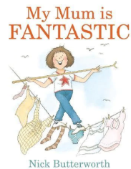
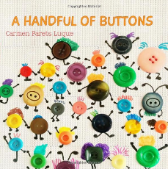
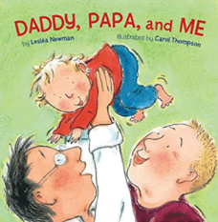

‘

Year 2  PSHE  Weekly | People Who Care For Me: Families
 | Word Aware Words: family, different, relationship, commitment
- Re-cap that all families can be different.
- The characteristics of healthy family life, commitment to each other, including in times of difficulty, protection and care for children and other family members, the importance of spending time together and sharing each other’s lives
- How to recognise if family relationships are making them feel unhappy or unsafe, and how to seek help or advice from others if needed.
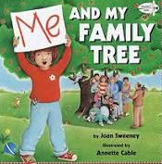
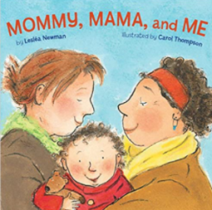
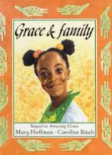

Year 1  PE  Weekly | Invasion Games
 | Word Aware: invade, speed, retrieve
 | - Master basic movements including running, jumping, throwing and catching, as well as developing balance, agility and co-ordination, and begin to apply these in a range of activities.  - participate in team games, developing simple tactics for attacking and defending | Premier Sports Coach | - Moving in and out of a space safely and with control  - Chasing and invading  - Invading to retrieve an object - giving a purpose to invade  - Small invasion games introducing basic rules |  |  | Play small invasion games using skills taught
 | Dance: Interpretive Dance – Under The Sea
 | Word Aware: Slow, fast, pace, high, low, levels
 | - Develop balance, agility and co-ordination, and begin to apply these in a range of activities.  - Perform dances using simple movement patterns. | The Snail and the Whale by Julia Donaldson  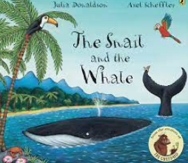 | - Explore moving in unison  - Follow and copy a partner  - Move and freeze with control and coordination  - Choose different movements to tell a story  - Create a simple dance motif.  - Observe and talk about each other’s dances. |  |  | Perform a dance using simple movement patterns
Year 2  PE  Weekly | Invasion Games
 | Word Aware: invade, attack, defend
 | - Master basic movements including running, jumping, throwing and catching, as well as developing balance, agility and co-ordination, and begin to apply these in a range of activities. | Premier Sports Coach | - Invading a space  - Defending a space  - Attacking - including attacking at speed  - Invasion games – including roles of attacking and defending as previously taught within unit  - Implement rules/scoring |  |  | Play invasion games using skills taught
 | Dance: Interpretive Dance – Pirates
 | Word Aware: motif, action, transition, levels, unison
 | - Develop balance, agility and co-ordination, and begin to apply these in a range of activities.  - Perform dances using simple movement patterns. |  | - Use and change direction  - Understand and perform simple basic travelling skills on feet  - Explore moving in unison  - Copy and develop a range of actions  - Combine actions together into a short movement phrase, creating a simple motif  - Observe a partner and give feedback. |  |  | - Perform a dance using simple movement patterns

